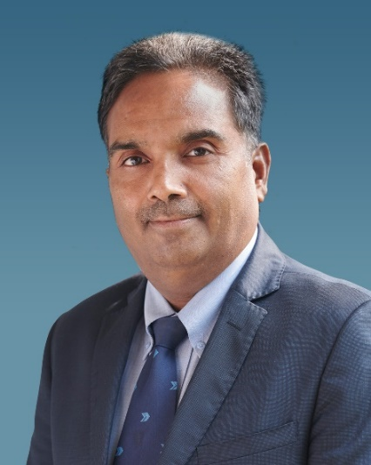

MR. MAHENDRA K GOYAL
Group President and Co-Chief Operating Officer,
ANAND Group

Mr. Mahendra K. Goyal, Group President, is one of the two Co-Chief Operating Officers of the ANAND Group. He is a member of the ANAND Executive Board. Mr Goyal is also the Managing Director of Dana Anand India, a joint venture between ANAND and Dana Incorporated, USA. He is directly responsible and accountable to the ANAND Executive Board for the following Group companies: HL Mando Anand India, a joint venture with Mando Corporation, part of the HL Group, Republic of Korea; Dana Anand India; ANAND I-Power; Haldex ANAND India; and MAHLE ANAND Filter Systems and MAHLE ANAND Thermal Systems, ANAND’s joint venture companies with MAHLE GmbH, Germany.

He is the chairman of HL Anand Automotive Parts Pvt. Ltd., which is a joint venture between HL Holdings Corporation and ANAND. In addition, he is responsible and accountable for the Group’s Aftermarket and Human Resource. He is also a member of the ANAND Management Forum, which oversees operational issues for the Group.

Mahendra is a chartered accountant, company secretary, and cost accountant with an Advanced Management Programme Certificate from Oxford University. He has dedicatedly served ANAND for over 28 years and handled positions of increasing responsibility in the areas of general management/operations, finance, treasury, corporate governance, board, and legal matters, among others. From his first assignment in 1995 with ANAND as Assistant Manager –Internal Audit, Mahendra has risen up the ranks swiftly to his position today. Mr. Goyal became Group Co-COO in 2021, in addition to serving as Group CFO, and played a key role in enhancing the financial systems, compliance, corporate governance, and relationships with joint venture partners.

